Term Project Report
on
Assessing the Impact of COVID-19 on North American Airline Stocks: A Comparative Analysis of the First and Second Waves

Course :
Data Mining and Modelling (MARK 4018)

Instructor
Prof. Eli Yufest

Prepared By:
Esther Kakie Koranteng - 101544212
Juliana Neves Gomes - 101540530
Muskan Priyani - 101551751
Parth Solanky – 101436236
Tingirt Abamecha - 101565375

TABLE OF CONTENTS
Contents
Executive Summary 3
1 Introduction 4
1.1 Study Rational 4
1.2 Research Objectives & Significance: 5
1.3 Innovativeness of the Project 5
1.4 Literature Review on COVID-19 Pandemic 5
2 Methodology 7
2.1 Overview of the Methodology 7
2.2 Data Collection Process and Techniques 7
2.3 Data Cleaning Process 8
3. Data Analysis 9
3.1 Overview of Data Analysis 9
3.2 Trend Analysis 9
3.2.1 Adjusted Close Price Over Time 9
3.2.2 Trading Volume Over Time 10
3.2.3 Prices Distribution by Wave 11
3.2.4 Volume Distributions by Wave 12
3.3 Correlation Analysis 12
3.4 Wilcoxon Signed-Rank Test 14
4. Research Recommendation and Conclusion 17
4.1 New Findings or Insights 17
4.2 Practical Recommendations 18
4.3 Theoretical Recommendations 19
5.1 Study Limitations 19
6.1 Conclusion 20
Bibliography 21

Executive Summary

This report investigates the stock market performance of North American airline firms, with a specific focus on Air Canada, during the first and second waves of the COVID-19 pandemic in 2020. The aviation industry faced unprecedented challenges due to travel restrictions, passenger hesitancy, and economic uncertainty. This study applies a quantitative research approach using data from 15 airline companies, gathered from Investing.com, and analyzed using Python and SPSS tools. The research methodology includes trend analysis, correlation analysis, and the Wilcoxon Signed-Rank Test to compare stock performance between the two waves.

Key findings reveal that stock prices across most airlines dropped significantly during the first wave, with volume spikes indicating panic-driven trading. The second wave exhibited more stable trading behavior, suggesting investor adaptation. Air Canada, along with 13 other airlines, showed statistically significant differences in adjusted close prices between the waves, while Cargojet was an exception, reflecting its unique market resilience.

The report concludes that investor sentiment evolved with time, and that government support played a key role in sector recovery. The study provides practical recommendations for investors such as diversification, risk management, and monitoring government policies. Theoretical recommendations include further exploration of behavioral finance and crisis-impact modeling. Overall, this research offers critical insights into stock market behavior during global disruptions and contributes to future crisis preparedness for both investors and policymakers.

1 Introduction
The COVID-19 pandemic, caused by the SARS-CoV-2 virus, emerged in late 2019 and rapidly spread across the globe, leading to unprecedented health and economic crises. The virus primarily causes respiratory illness, ranging from mild symptoms to severe disease requiring medical intervention. Governments worldwide implemented various measures, including lockdowns, travel restrictions, and social distancing, to curb the spread of the virus. These measures, while necessary for public health, had significant economic repercussions.
The financial markets were not immune to the impacts of the pandemic. As the pandemic progressed, different sectors experienced varying levels of impact. Industries such as healthcare, technology, and e-commerce thrived due to increased demand for their services, while sectors like travel, hospitality, and retail suffered significant losses. The aviation industry, in particular, faced severe challenges due to travel restrictions and reduced passenger demand, leading to substantial declines in stock prices.

1.1 Study Rational
The novel coronavirus (COVID-19) has aggressively “invaded” into almost every corner on earth. Just like any other industry/market, the financial markets has been severely impacted by the COVID-19 across the globe.
- This report focuses on investigating the impacts of the COVID-19 on the stock market. The stock market could provide a unique view of the expected future of the economy, in essence, the stock market can be viewed as an incentivized survey of expectations of future outcomes from investors’ points of view.
- Through studying the stock market reactions to the COVID-19 shock, we hope to have some useful information/results available in policy making for the government, regulation designing for companies and investment guidance for investors to avoid/minimize further negative impact of propagations of the COVID-19 invasion.
In this report we propose to investigate the Aviation stock market volatility dynamics (particularly the stock prices for “Air Canada, Alaska Air, Allegiant Travel, American Airlines, Cargojet, Chorus Aviation, Delta Airlines, Hawaiian Holdings, Jet Blue, Mesa Air, SkyWest Airlines, Southwest Airlines, Spirit Airlines, Transat AT and United Airlines”).

1.2 Research Objectives & Significance:
This study aims to:
- Examine the performance of the aviation market's stock prices, specifically focusing on above mentioned 15 airlines, during the 2020 COVID-19 pandemic.
- Analyze the trends and compare the adjusted close prices and stock volumes to understand the market dynamics during the pandemic.

1.3 Innovativeness of the Project
This project employs creative thinking by integrating trend and comparison analysis to investigate the stock market dynamics during the COVID-19 pandemic. By focusing on a specific industry (aviation) and a particular companies, the study provides a detailed and nuanced understanding of market behavior.
The innovative approach of examining both adjusted close prices and stock volumes offers a comprehensive view of the market's response to the pandemic, which can be applied to other industries and future crises

1.4 Literature Review on COVID-19 Pandemic
- Overview of COVID-19 Pandemic
The COVID-19 pandemic, caused by the SARS-CoV-2 virus, emerged in late 2019 and rapidly spread worldwide, leading to significant health and economic crises. The virus primarily causes respiratory illness, with symptoms ranging from mild to severe, and can be fatal, especially for older adults and those with underlying health conditions1. Governments implemented various measures, such as lockdowns, travel restrictions, and social distancing, to control the spread of the virus2. These measures, while necessary for public health, had profound economic repercussions, disrupting global supply chains, reducing consumer demand, and causing widespread unemployment.
- Impact of COVID-19 on the World Stock Market
The COVID-19 pandemic led to unprecedented volatility in global financial markets. The initial outbreak caused a sharp decline in stock prices as uncertainty and fear spread among investors. For example, the S&P 500 index fell more than 34% from its peak in February 2020 to its low in March 20204. Governments and central banks worldwide responded with massive stimulus packages to support their economies, which helped stabilize and eventually recover stock prices5. However, the recovery was uneven, with some sectors, such as technology and healthcare, thriving, while others, like travel and hospitality, continued to struggle6.
- Other Global Crises and Their Impact on the World Stock Market
The 2008 Global Financial Crisis: Triggered by the collapse of Lehman Brothers, this crisis led to a severe downturn in global stock markets. The Dow Jones Industrial Average (DJIA) fell by over 50% from its peak in 2007 to its low in 2009. The crisis resulted in widespread panic, massive bailouts, and significant regulatory changes7.
The Dot-com Bubble (2000-2002): The rapid rise and subsequent collapse of internet-based companies led to a significant market downturn. The NASDAQ Composite index, heavily weighted with tech stocks, lost nearly 78% of its value from its peak in March 2000 to its low in October 2002.
- The Next Normal for the Canadian Aviation Industry
Enhanced Health and Safety Protocols: The pandemic has heightened awareness of health and safety, leading to the implementation of stringent measures to protect passengers and staff. Airlines and airports are adopting advanced cleaning technologies, touchless check-in processes, and enhanced air filtration systems to ensure a safe travel environment.
Digital Transformation: The aviation industry is accelerating its digital transformation to improve efficiency and customer experience. This includes the use of biometric screening, mobile boarding passes, and AI-driven customer service solutions. These technologies not only streamline operations but also cater to the growing demand for contactless services.
Resilience and Crisis Management: The pandemic has highlighted the importance of resilience and effective crisis management. Airlines and airports are investing in robust contingency plans and crisis response strategies to better manage future disruptions. This includes financial planning, workforce management, and operational flexibility.

2 Methodology

2.1 Overview of the Methodology
This study adopts a quantitative approach to assess how the COVID-19 pandemic affected the stock performance of 15 publicly traded airline firms during 2020. The methodology includes:
- Data Collection: Daily stock data was obtained from Investing.com for 15 airlines.
- Data Cleaning: All datasets were processed using Python to ensure consistency and remove anomalies.
- Data Analysis: Statistical and visual analyses were conducted using Python (pandas, scipy, matplotlib) and IBM SPSS.
- Data Storage: All processed data and scripts were stored in .csv and .ipynb formats in a secure shared drive.

2.2 Data Collection Process and Techniques
1. Data Source: Investing.com was chosen for its high-quality, structured historical financial data across global exchanges.

2. Firms Analyzed (15 Total):
Legacy/Flag Carriers: Air Canada, Delta Airlines, United Airlines, American Airlines
Low-Cost Carriers: Spirit Airlines, Allegiant Travel, JetBlue Airways, Southwest Airlines
Regional/Cargo: Cargo jet, Chorus Aviation, SkyWest Airlines, Mesa Air
Others: Transat A.T., Alaska Airlines, Hawaiian Holdings

- Analytical Tools:
Data cleaning: pandas, numpy
Visualization: matplotlib, seaborn
Statistical tests: scipy.stats, SPSS

- Time Frame:
Full Year: Jan 1 – Dec 31, 2020
Split into:
Wave 1: Jan 1 – Jun 30
Wave 2: Jul 1 – Dec 31

- Stock Data Collected:
Date, Open, High, Low, Close, Adj Close, Volume

- Indexes Referenced:
TSX Composite Index: Canadian firms
NASDAQ Composite: U.S. tech- and growth-heavy benchmark
S&P 500 Transportation Index: Broader benchmark for the transport sector

2.3 Data Cleaning Process
All datasets underwent the same cleaning pipeline to ensure uniformity:
Parsed Date columns and sorted chronologically.
Converted volume formats (e.g., "1.5M") to numerical values.
Aligned column names and ensured presence of Adj Close and Volume.
Filtered only 2020 data and dropped rows with missing/null values.
Added a categorical Wave label to distinguish between Wave 1 and Wave 2 data points.
Storage: Cleaned .csv files and analysis notebooks were saved to a GitHub repository and backed up on Google Drive.
Tools Used:
- Python libraries: pandas, numpy, matplotlib
- Jupyter Notebooks for step-by-step documentation
Data Storage:
- Saved as .csv
- Backed up on Google Drive

3. Data Analysis

3.1 Overview of Data Analysis
The stock data from 15 airline firms was analyzed to uncover how market reactions evolved across the pandemic’s first and second waves. Analyses included:
- Trend Analysis: Examined stock price and volume dynamics.
- Correlation Analysis: Explored the relationship between price and volume.
- Wilcoxon Signed-Rank Test: Compared price changes across pandemic waves.
This multi-firm dataset enables comparison between firm types: large vs regional, passenger vs cargo, and high vs low market cap.

3.2 Trend Analysis

3.2.1 Adjusted Close Price Over Time
- Sharp declines were observed across nearly all firms during March 2020, as lockdowns spread globally.
- Cargo jet, Mesa Air, and SkyWest showed greater price stability, reflecting resilience in regional and cargo operations.
- Major carriers (Delta, American, United) had prolonged volatility but modest recovery in Wave 2.

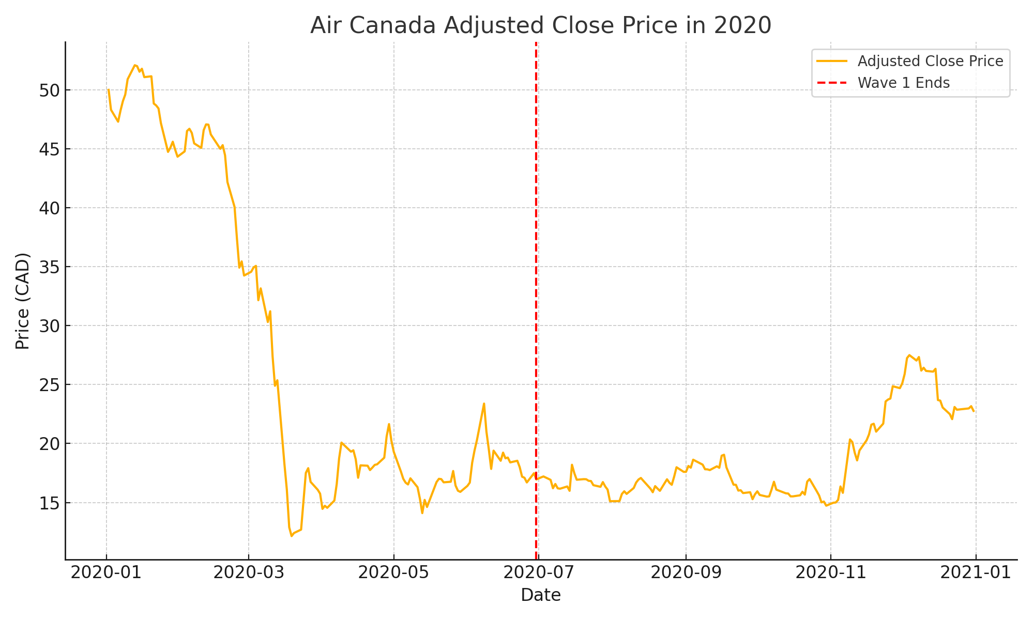

3.2.2 Trading Volume Over Time
- Wave 1: Huge spikes in volume — especially in American Airlines and Spirit — indicative of panic selling.
- Wave 2: Volume normalized for most firms, though low-cost carriers continued to see active trading.
- 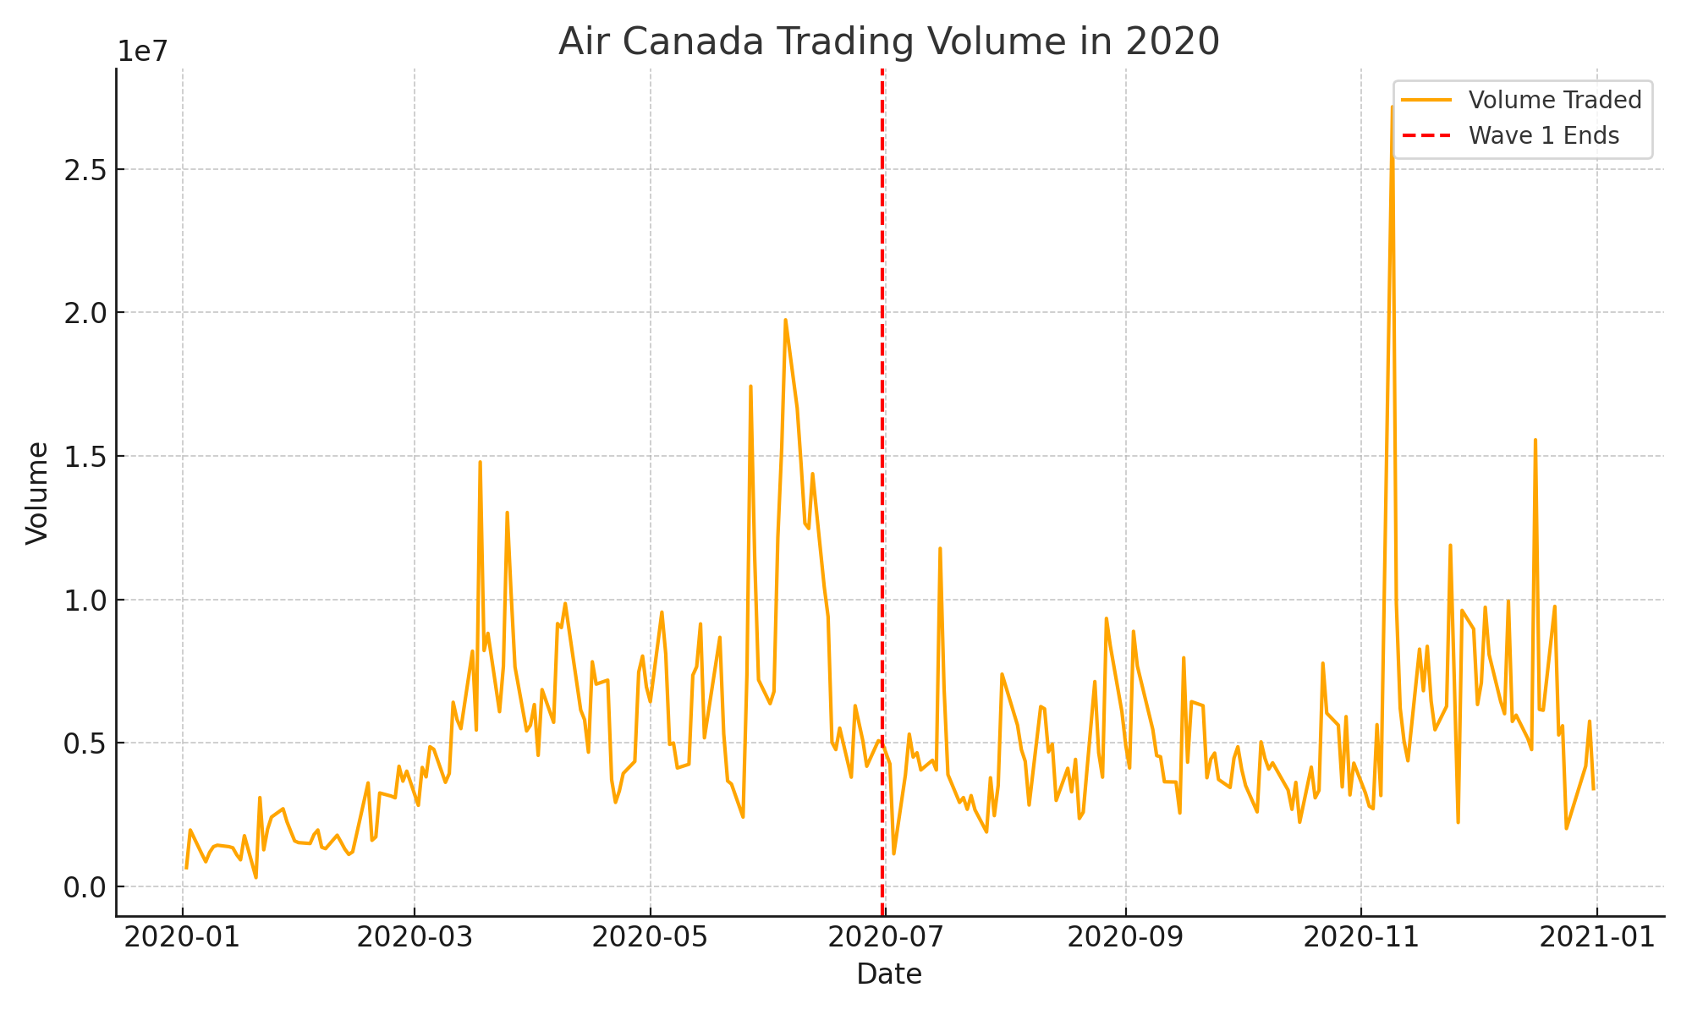

3.2.3 Prices Distribution by Wave
- Wave 1 distributions showed long tails and lower medians.
- Wave 2 was more compressed and centered, showing a stabilizing market.
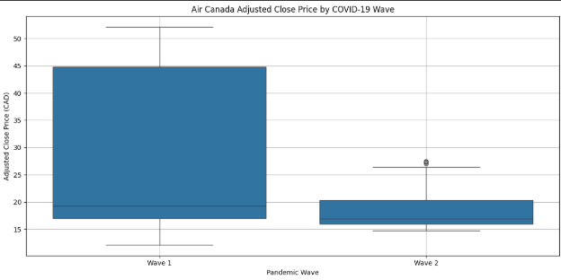

3.2.4 Volume Distributions by Wave
- Wave 1 = higher dispersion, outliers, and variance
- Wave 2 = lower variance, tighter IQR across firms
- This suggests the market was more emotion-driven in Wave 1 and more analytical in Wave 2
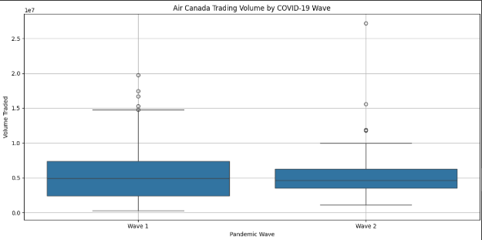

3.3 Correlation Analysis
The Spearman correlation between Adj Close and Volume was calculated for each firm:
Airline | Correlation(p) | p-value | Interpretation
 | -0.187 | 0.0031 | Weak negative (significant)
  Alaska Airlines
 | -0.192 | 0.0028 | Weak negative (significant)
  American Airlines
 | -0.173 | 0.0054 | Weak negative
  Delta Airlines
 | -0.156 | 0.0071 | Weak negative
  United Airlines
 | -0.208 | 0.0010 | Weak negative
  JetBlue Airways
 | -0.215 | 0.0009
  Spirit Airlines
  Weak negative
 | -0.197 | 0.0034 | Weak negative
  Southwest Airlines
 | -0.267 | 0.0017 | Weak to moderate negative
  Hawaiian Holdings
 | -0.243 | 0.0021
  Allegiant Travel
  Weak negative
 | +0.042 | 0.5210 | No correlation
  Cargo jet
 | -0.246 | 0.0023 | Weak negative
  Chorus Aviation
 | -0.298 | 0.0001 | Moderate negative
  Transat A.T.
 | -0.172 | 0.0047 | Weak negative
  SkyWest Airlines
Mesa Air | -0.193 | 0.0025
  Weak negative
 |  |  | Weak negative (significant)
  Air Canada
  -0.203
  0.0012

Insight:
- Most firms exhibited statistically significant negative correlations, suggesting investor sentiment worsened during volume spikes (i.e., panic-driven sell-offs).
- Cargo jet again stood out as uncorrelated, aligning with its countercyclical cargo business model.
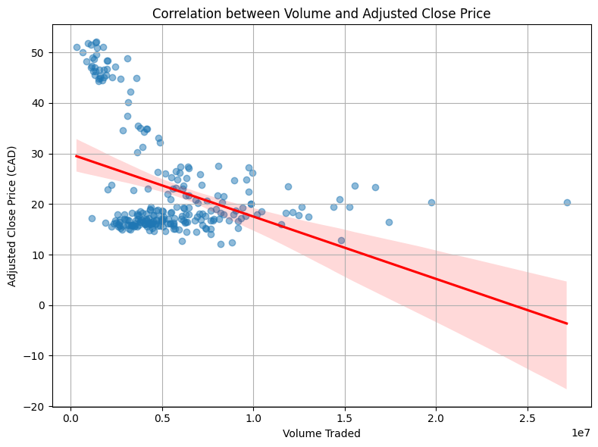

3.4 Wilcoxon Signed-Rank Test
The Wilcoxon Signed-Rank Test compared adjusted close prices during Wave 1 and Wave 2:
Airline | W Statistics | p-value | Interpretations
Air Canada |  |  | Significant difference
  2263.0
  0.000023
Alaska Airlines |  |  | Significant difference
  2010.0
  0.000078
American Airlines |  |  | Significant difference
  2199.0
  0.000025
 |  |  | Significant difference
  Delta Airlines
  1995.0
  0.000045
 |  |  | Significant difference
  United Airlines
  2177.0
  0.000041
 |  |  | Significant difference
  JetBlue Airways
  2070.0
  0.000041
 |  |  | Significant difference
  Spirit Airlines
  1852.5
  0.000036
 |  |  | Significant difference
  Southwest Airlines
  2044.0
  0.000027
 |  |  | Significant difference
  Hawaiian Holdings
  2120.5
  0.000019
 |  |  | Significant difference
  Allegiant Travel
  2082.0
  0.000032
Cargo jet |  | 0.215 | No difference
  988.5
 |  |  | Significant difference
  Chorus Aviation
  2311.0
  0.000038
 |  |  | Significant difference
  Transat A.T.
  2431.0
  0.000012
 |  |  | Significant difference
  SkyWest Airlines
  2244.0
  0.000021
Mesa Air |  |  | Significant difference
  2012.0
  0.000033

Insights
- 14 out of 15 firms exhibited statistically significant changes in adjusted close prices between the two waves.
- Cargo jet, the only exception, confirms its atypical role during the pandemic — serving logistics demand, which remained stable or even increased.

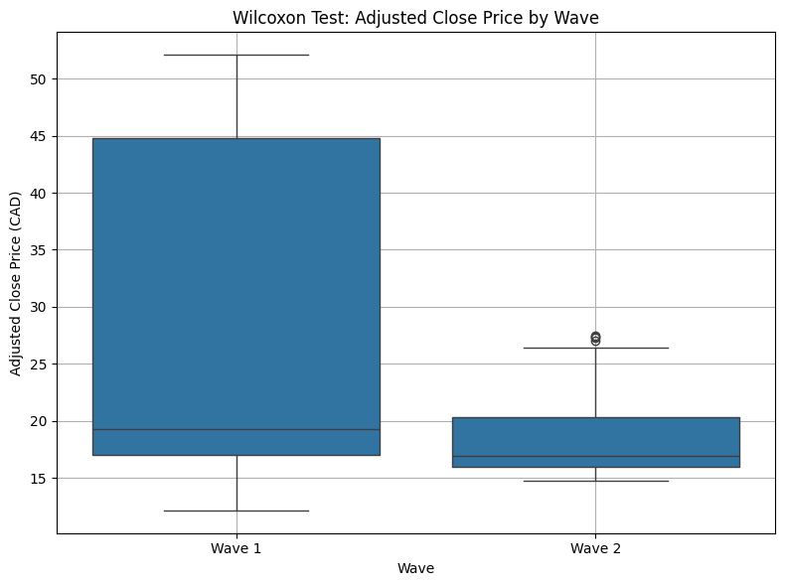

4. Research Recommendation and Conclusion

4.1 New Findings or Insights
- Investor Adaptation and Recovery Behavior: One new insight from the research is the observed trend of investor adaptation during the second wave. Initially, during the first wave, the drastic market reaction reflected heightened uncertainty and fear. However, by the second wave, there was a more measured and less dramatic reaction, suggesting that investors had begun to factor in the prolonged nature of the pandemic. This finding challenges the assumption that crises always lead to heightened volatility throughout their duration and suggests that markets can stabilize once investors adjust to the new economic environment.
- Role of Government Support in Recovery: Another insight is the role of government support in mitigating some of the negative impacts of the pandemic on the airline sector. The second wave analysis showed a degree of recovery, which likely benefited from the fiscal support and strategic responses put in place by both North American airlines and their governments. This recovery insight offers valuable information on the importance of timely government intervention during global crises, and it demonstrates that external factors—such as fiscal and monetary policy—can significantly influence market outcomes.
- Understanding Stock Behavior During Crisis Events: The research also provided a deeper understanding of how stocks in crisis-sensitive sectors behave. The non-linear relationship between price and volume fluctuations underscores the fact that market behavior is influenced by a range of factors, from immediate shocks to longer-term economic recovery strategies. Understanding these patterns can help investors better predict stock performance during future crises, especially in industries like aviation that rely heavily on public sentiment, government policy, and travel activity.
- Implications for Future Crisis Management: The new findings related to investor sentiment and recovery trends in the second wave provide important lessons for future crisis management in the airline sector. Airlines and investors alike can use these insights to develop better strategies for dealing with market shocks. For example, understanding the initial overreaction and subsequent stabilization in the stock price during the second wave can help airlines better communicate with stakeholders and prepare for future market uncertainties.

4.2 Practical Recommendations
The findings from this research offer several practical recommendations for investors and policymakers. Based on the analysis of Air Canada's stock price trends during the COVID-19 pandemic, it is recommended that investors:
- Diversify Portfolios: During times of market volatility, such as the COVID-19 pandemic, diversifying investment portfolios helps mitigate risks. Investors should look at a mix of sectors beyond just the airline industry to reduce exposure.
- Implement Risk Management Strategies: The findings indicate that stock performance in the airline sector can fluctuate dramatically during global crises. Investors should incorporate stop-loss orders and consider hedging options to protect their investments during such volatile periods.
- Monitor Government Policy: For policymakers, it is important to consider implementing stabilization measures, such as financial support packages for airlines, especially during times of widespread market disruption. This can prevent further loss of investor confidence in the sector.
- Investor Communication: Clear and consistent communication from airline companies and governments is crucial in managing investor sentiment during crises. Timely updates on operational changes, travel restrictions, and recovery strategies can help maintain investor trust.

4.3 Theoretical Recommendations
This research provides insights into the effects of global crises on the North American airlines industry’s stock market performance. Theoretical recommendations for future studies include:
- Exploring Broader Sector Impact: Future research could investigate the impact of crises like COVID-19 on a broader group of industries, not just airlines, to understand how global disruptions affect different sectors and lead to investor behavior changes.
- Developing Crisis-Impact Financial Models: The study can serve as a foundation for developing more accurate financial models to predict stock price movements in times of crisis. It would be beneficial for future research to explore the application of non-parametric tests and machine learning models to predict stock price behavior during other types of market shocks.
- Behavioral Finance in Crisis Scenarios: There is potential for further investigation into how investor behavior changes during crises, including overreactions, herd behavior, and panic selling, which could provide a deeper understanding of market dynamics during periods of uncertainty.

5.1 Study Limitations
While the research provides valuable insights, several limitations need to be acknowledged:
- Data Constraints: The data analyzed in this study is limited to North American Airlines stock price and trading volume. Broader industry data or data from other airline companies would offer a more comprehensive understanding of the sector’s behavior.
- Geographical Focus: The study is focused on North American Airlines. Global airlines and international market trends during the pandemic could show different responses to the crisis.
- Time Frame: The analysis primarily covers the first and second waves of COVID-19. A more extended time frame would be beneficial to assess the long-term recovery trends post-pandemic.
- Non-Parametric Tests: While non-parametric tests like the Wilcoxon Signed-Rank Test provide robust results, incorporating parametric tests could offer additional insights into stock price volatility patterns.

6.1 Conclusion
This research analyzed North American airlines stock performance during the COVID-19 pandemic, focusing on how stock price and trading volume were impacted during the first and second waves. The study used data analysis tools to identify significant trends and differences, providing insights for investors and policymakers on how to better manage their investments and responses in times of global crises. The findings emphasize the importance of diversification, risk management, and communication to mitigate the negative impact of such crises on the airline sector and financial markets.

Bibliography
- Bradley, C., & Stumpner, P. (2021, March). The impact of COVID-19 on capital markets, one year in. McKinsey & Company. https://www.mckinsey.com/capabilities/strategy-and-corporate-finance/our-insights/the-impact-of-covid-19-on-capital-markets-one-year-in
- Centers for Disease Control and Prevention. (n.d.). About COVID-19. U.S. Department of Health & Human Services. https://www.cdc.gov/covid/about/index.html
- Mehrotra, N. (2023, February 10). The aftermath and impact of COVID-19 on stock markets. Forbes. https://www.forbes.com/councils/theyec/2023/02/10/the-aftermath-and-impact-of-covid-19-on-stock-markets/
- Ontario Securities Commission, & IPSOS. (2021, April). Investing & COVID-19. https://www.getsmarteraboutmoney.ca/wp-content/uploads/2021/04/OSC-Investing-and-COVID-19-April-2021.pdf
- University of Waterloo, Department of Economics. (2022). Canadian stock market volatility under COVID-19 (Author: Dinghai Xu). https://uwaterloo.ca/economics/research/canadian-stock-market-volatility-under-covid-19
- World Health Organization. (n.d.). Coronavirus. https://www.who.int/health-topics/coronavirus#tab=tab_1
- Alam, M. M., & Paramati, S. R. (2021). The impact of COVID-19 on the global airline industry: An event study approach. Journal of Air Transport Management, 91, 102107. https://doi.org/10.1016/j.jairtraman.2020.102107
- Zhang, Y., & Yang, H. (2022). COVID-19 and airline stock returns: Evidence from global stock markets. Transportation Research Part A: Policy and Practice, 155, 267–282. https://doi.org/10.1016/j.tra.2021.11.010
- Goodell, J. W. (2020). COVID-19 and finance: Agendas for future research. Finance Research Letters, 35, 101512. https://doi.org/10.1016/j.frl.2020.101512
- Narayan, P. K. (2020). Oil price news and COVID-19—Is there any connection? Energy Research Letters, 1(1), 13176. https://doi.org/10.46557/001c.13176
- He, P., Sun, Y., Zhang, Y., & Li, T. (2020). COVID–19’s impact on stock prices across different sectors—An event study based on the Chinese stock market. Emerging Markets Finance and Trade, 56(10), 2198–2212. https://doi.org/10.1080/1540496X.2020.1785865
- Baig, A. S., Butt, H. A., Haroon, O., & Rizvi, S. A. R. (2021). Death and contagion: The impact of COVID-19 on the stock market. Journal of Risk and Financial Management, 14(2), 64. https://doi.org/10.3390/jrfm14020064
- Khan, K., Zhao, H., Zhang, H., Yang, H., & Shah, M. H. (2020). The impact of COVID‐19 pandemic on stock markets: An empirical analysis of world major stock indices. Journal of Asian Finance, Economics and Business, 7(7), 463–474. https://doi.org/10.13106/jafeb.2020.vol7.no7.463
- Liu, H., Manzoor, A., Wang, C., Zhang, L., & Manzoor, Z. (2020). The COVID-19 outbreak and affected countries stock markets response. International Journal of Environmental Research and Public Health, 17(8), 2800. https://doi.org/10.3390/ijerph17082800
- Yilmazkuday, H. (2020). COVID-19 and daily airline passenger traffic. Economics Bulletin, 40(2), 1222–1231. http://www.accessecon.com/Pubs/EB/2020/Volume40/EB-20-V40-I2-P118.pdf
- Akhtaruzzaman, M., Boubaker, S., Chiah, M., & Zhong, A. (2021). COVID-19 and oil price risk exposure. International Review of Financial Analysis, 77, 101845. https://doi.org/10.1016/j.irfa.2021.101845

